Zoom Panel Intro

### **Upcoming Expert Panel Webinar Series: Veterinary Culture & Leadership Panel**

**Webinar Title:** **From Stuck to Thriving: Redefining Leadership, Communication, and Culture in Modern Veterinary Practices**

**Overview:** Today’s veterinary landscape demands more than clinical expertise — it calls for strong, compassionate leadership and a workplace culture that supports growth, accountability, and well-being. This dynamic panel discussion brings together leading experts and practice owners to share actionable strategies for transforming team dynamics, fostering open communication, and redefining what leadership looks like in modern veterinary practices.

Join us for an interactive, high-impact conversation designed to help veterinary professionals at all levels lead with confidence, clarity, and heart.

- **Date:** Wednesday, October 8, 2025  
- **Time:** 8:00 PM – 9:00 PM EST  
- **Duration:** 1 Hour

**- Format:** Live Panel Discussion + Interactive Q&A Session  
 **- Streaming On:** LinkedIn and Facebook  
 **- Registration:** Complimentary

### **Key Discussion Topics**

* **From Managing to Leading:** How to move beyond task management and lead with vision, purpose, and trust.
* **The Power of Communication:** Proven ways to create psychological safety, reduce turnover, and boost team morale through open dialogue.
* **Building Feedback-Driven Teams:** How to foster a culture where feedback is not feared but embraced as a path to growth.
* **Values in Action:** Aligning your practice’s mission and values with daily behaviors and decision-making.
* **Empathy Meets Accountability:** Balancing compassion with high performance to build motivated, resilient teams.

**🎙️ Number of Speakers:** 2–3 expert panelists  
 **🧭 Audience:** Veterinarians, practice managers, technicians, and anyone committed to cultivating healthy, thriving practice cultures.

Dr Andrew Findlaytor

* Full Name: Dr Andrew Findlaytor
* Contact Number: 707 761 9020
* Current Position and Organization: Co-founder at Vetsie
* Professional Headshot: Attached
* Email Address: [amfindlaytor@gmail.com](mailto:amfindlaytor@gmail.com)

Bio:

Dr. Andrew Findlaytor is a proud veterinarian, educator, and entrepreneur focused on building

practical tools that support real-world veterinary teams. His career spans nearly every facet of

veterinary medicine: from working as a veterinary assistant, to practicing at close to 100

hospitals across referral, general practice, urgent care, ER, rural, and shelter settings, to serving

as Chief Veterinarian at Roo, where he supported one of the nation’s largest communities of

relief professionals. He is now the co-founder of Vetsie, a modern clinical library built to bring

clarity and support to busy practitioners. Dr. Findlaytor speaks nationally on spectrum of care,

technician empowerment, relief medicine, and innovation in the veterinary profession.

Short Bio:

Dr. Andrew Findlaytor is a proud veterinarian, educator, and entrepreneur dedicated to building

tools that support real-world veterinary teams. His career spans nearly every facet of veterinary

medicine, from kennel tech to Chief Veterinarian at Roo, and now co-founder of Vetsie, a

modern clinical library designed to bring clarity and confidence to busy practitioners.

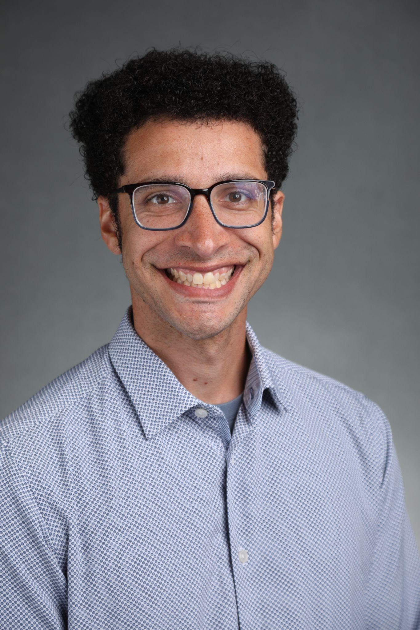

Aaron Massecar

* Full Name: [**Aaron Massecar**](https://www.linkedin.com/in/aaron-massecar/overlay/about-this-profile/)
* Contact Number: 979-633-8098
* Current Position and Organization: Vice President, Partnerships
* Email Address: [amassecar@co.vet](mailto:amassecar@co.vet), [Aaron Massecar](mailto:aaron.massecar@gmail.com)  
    
  First work in veterinary medicine was with Texas A&M where I helped to build the Veterinary Entrepreneurship Academy and the Veterinary Innovation Summit. I later started working on telemedicine with the Veterinary Innovation Council in 2017. While at VIC, I helped to build educational programs for the North American Veterinary Community and later became the Senior Vice President of Learning at the NAVC. A couple of senior executive positions with Colorado State University’s Translational Medicine Institute and the Veterinary Emergency Group, now I am back at the Veterinary Innovation Council and helping to drive awareness across the industry in domains such as innovation, entrepreneurship, and artificial intelligence.

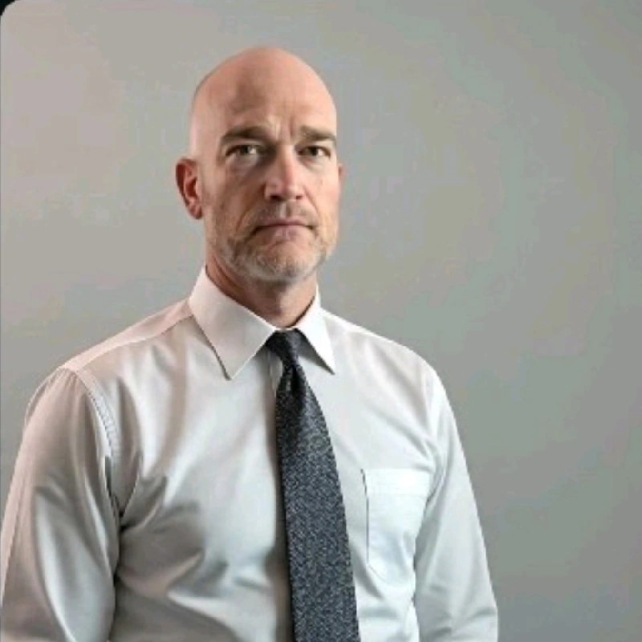

Jennifer Edwards

* Full Name: **Jennifer Edwards**
* Contact Number: 603-759-3295
* Current Position and Organization: Leadership & Energy Coach • Speaker • Veterinarian • Canfield Success Principles Trainer
* Email Address:

certified professional coach (iPEC, ACC–ICF) specializing in leadership and life [Jennifer@drjenniferedwards.com](mailto:Jennifer@drjenniferedwards.com)transitions. My approach blends science and intuition to help leaders—especially women—move from burnout and uncertainty to clarity, energy, and purpose.

I believe transformation starts with mindset, energy, and conscious choice. Through coaching, I help individuals and teams shift culture, strengthen communication, and create environments where people thrive.

While I have deep roots in the veterinary community, my work now spans industries—because everyone leads, whether at work, at home, or in life.

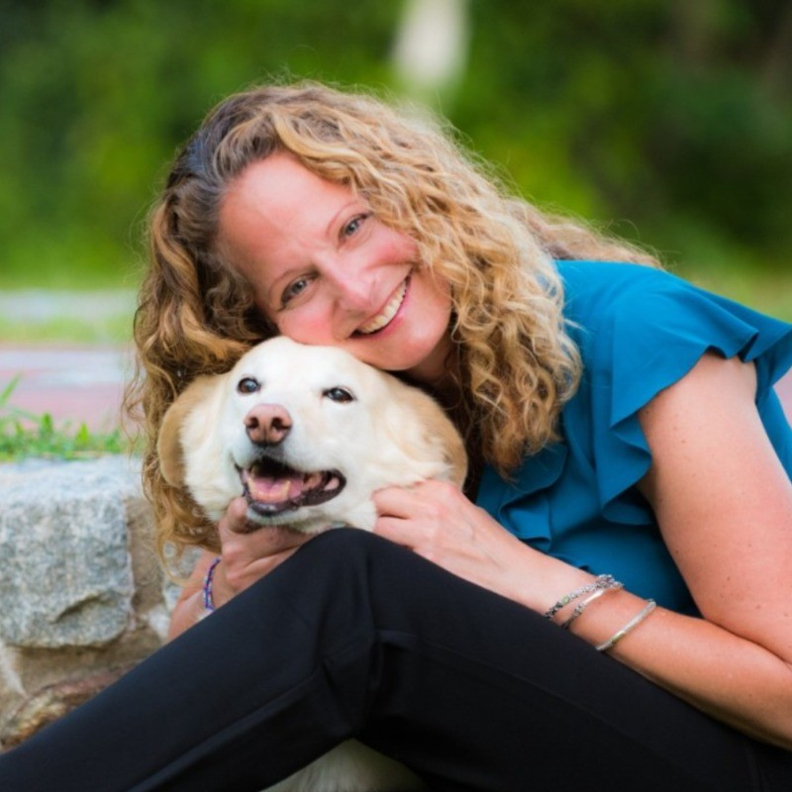

Suzanne (De Salvo) Thomas

* Full Name: Suzanne (De Salvo) Thomas
* Contact Number:
* Current Position and Organization:
* Email Address: [suzanne@lvt.vet](mailto:suzanne@lvt.vet)

Veterinary leadership isn’t about managing tasks—it’s about empowering people. Most leaders weren’t trained for that, and that’s where I come in.

Through **leadership coaching**, **team development**, and **veterinary nurse/technician empowerment**, I help practices shift from managing to truly leading.

✔ Build confident, supported leaders  
 ✔ Empower nurses and technicians to work at the top of their skills  
 ✔ Create a culture of trust, learning, and accountability

I founded **Leading Veterinary Teams, LLC** to equip leaders with the mindset, tools, and community to lead with clarity and heart—without burning out.

